**Mahavir Education Trust's**

Shah & Anchor Kutchhi Engineering College,

**Chembur, Mumbai 400 088**

UG Program in Information Technology

|  |  |  |  |  |  |
| --- | --- | --- | --- | --- | --- |
| **Experiment No. 1** | | | | | |
| **Date of Performance:** |  | | | | |
| **Date of Submission:** |  | | | | |
| **Program formation/ Execution/**  **ethical practices (07)** | **Documentation (02)** | **Timely Submission (03)** | **Viva Answer (03)** | **Experiment Marks (15)** | **Teacher Signature with date** |
|  |  |  |  |  |  |

**NAME: KRISHA SAYLA**

**ROLL.NO: 70**

**CLASS: TE-6**

**Experiment No. 1**

**Aim:** To Understand DevOps: Principles, Practices, DevOps Engineer Roles and Responsibilities.

**Lab Outcome:**  To understand the fundamentals of DevOps engineering and be fully proficient with DevOps terminologies, concepts, benefits, and deployment options to meet your business requirements

**Theory:**

**DevOps Definition:**

The DevOps is a combination of two words, one is software Development, and second is Operations. This allows a single team to handle the entire application lifecycle, from development to testing, deployment, and operations. DevOps helps you to reduce the disconnection between software developers, quality assurance (QA) engineers, and system administrators.

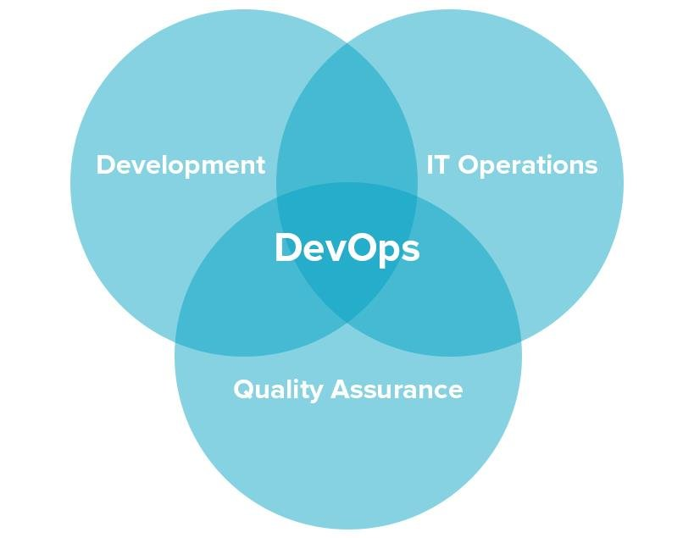

**DevOps Principles:**

The main principles of DevOps are Continuous delivery, automation, and fast reaction to the feedback.

1. **End to End Responsibility:** DevOps team need to provide performance support until they become the end of life. It enhances the responsibility and the quality of the products engineered.
2. **Continuous Improvement:** DevOps culture focuses on continuous improvement to minimize waste. It continuously speeds up the growth of products or services offered.
3. **Automate Everything:** Automation is an essential principle of the DevOps process. This is for software development and also for the entire infrastructure landscape.
4. **Custom Centric Action:** DevOps team must take customer-centric for that they should continuously invest in products and services.
5. **Monitor and test everything:** The DevOps team needs to have robust monitoring and testing procedures.
6. **Work as one team:** In the DevOps culture role of the designers, developers, and testers are already defined. All they needed to do is work as one team with complete collaboration.

**DevOps Practices:**

Some identified DevOps practices are:

* Self-service configuration
* Continuous build
* Continuous integration
* Continuous delivery
* Incremental testing
* Automated provisioning
* Automated release management

**DevOps Engineer Roles and Responsibilities:**

DevOps engineers work full time. They are responsible for the production and continuing maintenance of a software application platform.

Below are some roles, responsibilities, and skills which are expected from DevOps engineers, such as:

* Manage projects effectively through an open standard based platform.
* Increases project visibility through traceability.
* Improve quality and reduce the development cost with collaboration.
* DevOps should have the soft skill of problem solver and a quick learner.
* Analyze, design, and evaluate automation scripts and systems.
* Able to perform system troubleshooting and problem-solving across the platform and application domains.
* Ensuring the critical resolution of system issues by using the best cloud security solution services.

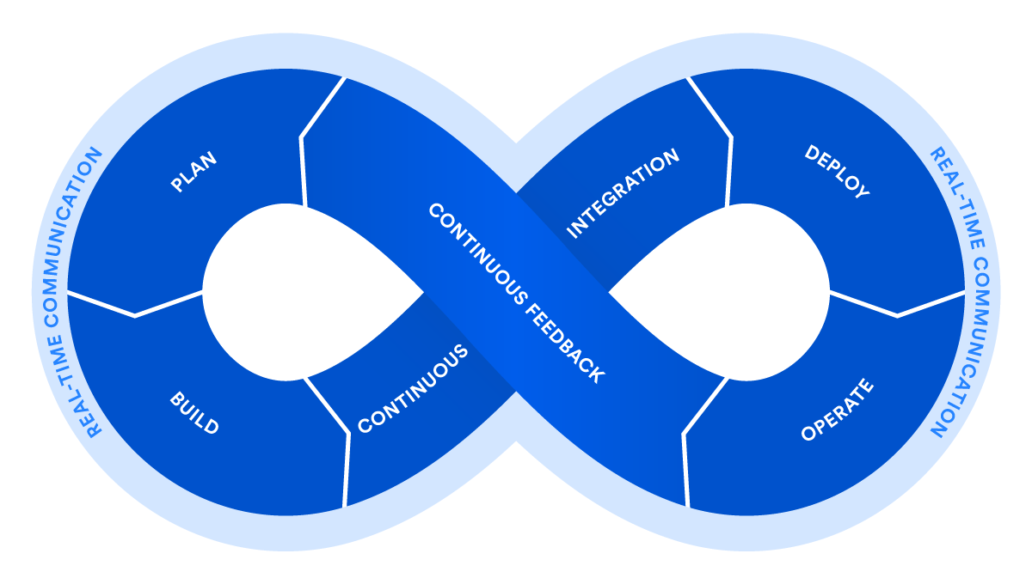

Conclusion:

The basic introduction and the DevOps concept were clearly explained in this experience. The definition, principles and practices for DevOps were understood.